LAB09 - SPI port (simulated) using bit-banging.
In this LAB you will simulate the SPI port by using bit-banging. You also will be use Logic Analyzer for signal visualization.
Part A – SPI sender.
In Part A you should make an assembler program that will send four bytes over simulated SPI port. Four bytes are 0x55, 0xAA, 0x81 and 0x2A. The expected result is (Picture on the ‘Logic Analyzer’):
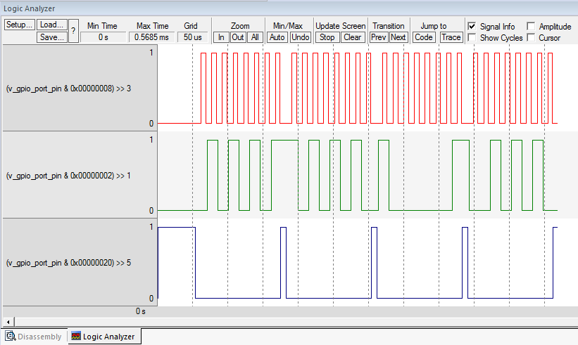
First signal (RED) is CLK, second (GREEN) is MOSI and third (BLUE) is SS.
1. Create the directory named 'Lab09'. Download, unzip and copy the file 'Template_Lab09_PartA.s' into your 'Lab09' directory. Rename 'Template_Lab09_PartA.s' to 'JoeTheStudent_Lab09_PartA.s' where 'JoeTheStudent' is your name or canvas login. Open 'Keil uVision' and create new project 'Lab09' like you did it for Lab06, Lab07 and Lab08. Use the same project's settings as you used for Lab08 (Set ‘simulator’ as debug device). Add 'JoeTheStudent_Lab09_PartA.s' and 'LPC4088\ startup_LPC407x_8x_177x_8x.s' files into your project. Open 'JoeTheStudent_Lab09_PartA.s' file.
2. Define ‘virtual GPIO Pin register’ in DATA memory. See slide #24 of lecture presentation for example. It is recommended to use 32-bit variable, because it is better for Logic Analyzer. Make this variable GLOBAL (use GLOBAL or EXTERNAL assembler instruction) as you did it in previous Lab08.
3. You will use bit 1 as MOSI, bit 3 as CLK and bit 5 as SS. The delay constant will be 10. Those definitions already done in template file. Locate the lines:
SS EQU BIT5
CLK EQU BIT3
MOSI EQU BIT1

spi_delay EQU 10

at the top of the file.
4. You will reuse the 'delay' function you did for Lab06. Copy the procedure from your Lab06. Do some changes if necessary. You may want to use different register for ‘delay time’ parameter. Make sure you are preserving your ‘delay time’ parameter value. It may help to make your code shorter.
5. Write your ‘spi_slot’ function. It should be similar to one on the slide #27 of lecture presentation. You may want to change the name ‘virtual_gpio_pin_register’ to name of your ‘virtual port’ variable. You also may want to change registers used for delay parameter, working variables, and, probably, for input parameter. Follow to common good practice for functions:
- Use BL command to call the function!
- Store all registers used in function into stack!
- Do not store register(s) that will return the result!
- Number of register(s) in PUSH and POP commands should match!
- Store LR into stack as well
- Use POP {…, PC} as ‘return’ command
6. Write your ‘send_byte’ function. On lecture you have discussed how to do it. Use slide #28 of lecture presentation for guidelines. It is your part of job, to write the function on assembler. You have enough knowledge to do it!
Again, overall algorithm is (suppose you are sending Rx):
Save working registers into stack
Set SS line Low
Repeat 8 times:
Call ‘spi_slot’
Shift register Rx to left by one bit
Set SS line High
Call ‘delay’
Restore saved registers from the stack and return.

6.A. Probably you will want to ‘optimize’ your code and make it a little bit faster, shorter or both. For example, you can move commands
LDR R0, =virtual_gpio_pin_register
LDR R3, =spi_delay
from ‘spi_slot’ function to ‘send_byte’ function and pass those register to ‘spi_slot’ as parameters. It will make your program a little bit faster. You may figure out some other ‘optimization’.
7. Write your ‘SystemInit’ function. In this function you will need to set initial values for your ‘virtual pins’. SS should be ‘1’ and MOSI and CLK should be ‘0’.

Also, it is good to make some initial delay here (call your ‘delay’ function). The parameter like 100 for your ‘delay’ function will be ok.

8. Finally, write your ‘__main’ program.

You have to send four bytes over simulated SPI:

0x55, 0xAA, 0x81 and 0x2A.

You may do it by two ways:
8.A. Call ‘send_byte’ four times, each time with new argument. (Suppose your ‘send_byte’ function sends data from register Rx):
MOV Rx, #0x55
BL send_byte
MOV Rx, #0xAA
BL send_byte
MOV Rx, #0x81
BL send_byte
MOV Rx, #0x2A
BL send_byte

8.B. Store your four bytes in the FLASH:

bytes_to_send DCB 0x55, 0xAA, 0x81, 0x2A

and make some additional loop to read your numbers from the flash and pass each number into ‘send_byte’.
Either way is ok, it is your choice what to do.

9. When you are ready to run your program, you have to setup the Analyzer. See the slide #30 in lecture presentation for example. Your signals are ‘bits’ in one global variable. You may set up the analyzed to show bits.
To do it, you have to add your variable, following the dot and bit number.
For example: The name of your ‘virtual port’ variable is ‘my_virtual_port’.
To add ‘MOSI’ line (Bit 1) into logic analyzer, you should type:
my_virtual_port.1
And, then, select ‘Byte’ for ‘Display Type’ drop box.
To add ‘SS’ (bit 5), type ‘my_virtual_port.5’, etc.
10. Run the program and make sure yours signal matching the expected signals (picture of expected signals is at the top of the document). Save and submit your project for grading.
Part B – SPI receiver (simulated) using bit-banging.
In this part you will write the SPI receiver using bit banging. This is a little bit more complex task than Part A. But it is doable!
1. Make ‘Lab09_B’ folder in your CS107 root directory. Unzip ‘Lab09_PartB.zip’ into ‘Lab09_B’ folder. Rename ‘Template_Lab09_PartB.s’ to 'JoeTheStudent_Lab09_PartB.s' where 'JoeTheStudent' is your name or canvas login. Open 'Keil uVision' and open Lab09_B project. Add your 'JoeTheStudent_Lab09_PartB.s' into the project, compile and load.
Then set the breakpoint on line with instructions:
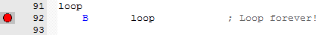
Open Logic Analyzer window.
Run the program. On Logic Analyzer you will see:
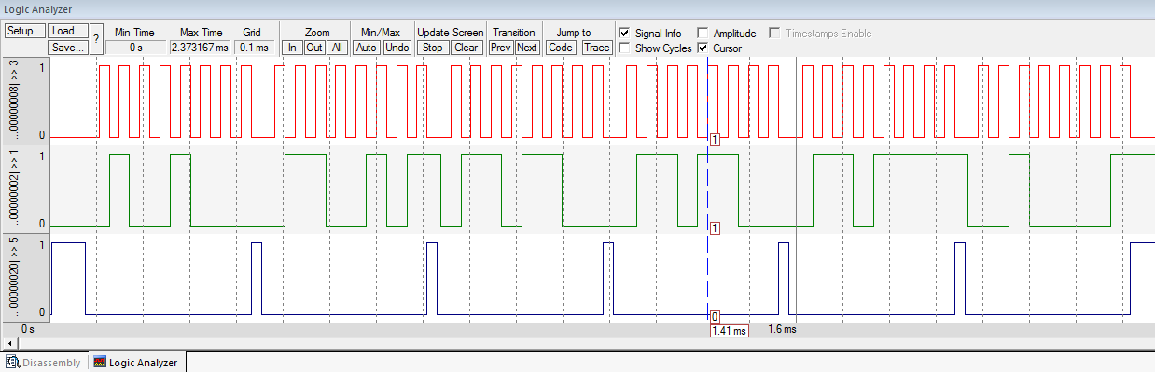
Looks familiar? Yes! This is an SPI signals. The small program in ‘Template’ file getting recorded (generated by simple Python script, actually) SPI signals and playing it back into ‘virtual_gpio’ variable. Bits 1, 3 and 5 of ‘virtual_gpio’ are MOSI, CLK as SS lines. Those bits are connected to Logic Analyzer, so you can see it on your screen.
The data format is: 8 bits per transmission (i. e. one byte), most significant bit (bit 7) is first, LSB (bit0) is last. The MOSI is sampled on rising edge (from 0 to 1) of CLK signal.
SPI signals are stored in FLASH in arrays with names ‘spi_input’ and ‘spi_input_1’. You have two test sets to run. Sizes of arrays are defined as ‘n_input’ and ‘n_input1’.
Then look at the following lines:
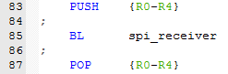
The ‘playback’ program calls your ‘spi_receiver’ function each time it put new recorded value from ‘spi_input’ (or ‘spi_input_1’).
Your ‘spi_receiver’ function should read ‘virtual_gpio’ variable and process SPI signals to read bytes from ‘virtual interface’ and store bytes to some data buffer in DATA memory. Result may be visible in ‘Memory’ window. For ‘spi_input’ array the correct answer is ‘Hello!’:
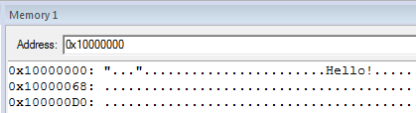
Pleae note: your ‘spi_receiver’ function cannot read ‘spi_input’ and ‘spi_input_1’ directly. ‘spi_receiver’ can read only ‘virtual_gpio’ and any yours constant or variable. It is supposed that ‘spi_receiver’ has no any parameters. We are pretending that ‘virtual_gpio’ is and input GPIO port. So we know only it’s current status of input lines, no any previous status of lines, no any future one.
2. To decode SPI signals you will have at least 3 variables:
RX_DATA – This is a ‘shift register’ for incoming data bits.
BIT_COUNT – Counter for incoming bit.
ADDR_TO_STORE – Address in DATA memory to store next byte received.

The approximate algorithm for ‘spi_receiver’ (Python-like pseudocde):
if (CLK changing from 0 to 1):
if (SS == 0):
RX_DATA = RX_DATA << 1 # Left arithmetic shift of RX_DATA by one bit.
if (MOSI == 1):
RX_DATA = RX_DATA | 1 # Put ‘1’ into Bit0 of RX_DATA
BIT_COUNT = BIT_COUNT + 1
if BIT_COUNT == 8:
MEM[ADDR_TO_STORE] = RX_DATA # Store received byte to memory buffer
ADDR_TO_STORE = ADDR_TO_STORE + 1
RX_DATA = 0
BIT_COUNT = 0

CLK, SS and MOSI are SPI ‘lines’ coming from ‘virtual_gpio’.

The one problem here is ‘CLK changing from 0 to 1’. How to detect if CLK line is changing from 0 to 1? Again: you can read only ‘virtual_gpio’ variable. You cannot read any number from ‘spi_input’ and ‘spi_input_1’.

The one way is to make additional variable and keep the previous level of CLK signal. Let’s say that this variable has the name ‘PREV_CLK’. Then, the code will be something like this:

if (PREV_CLK == 0 AND CLK == 1):
if (SS == 0):
RX_DATA = RX_DATA << 1 # Left arithmetic shift of RX_DATA by one bit.
if (MOSI == 1):
RX_DATA = RX_DATA | 1 # Put ‘1’ into Bit0 of RX_DATA
BIT_COUNT = BIT_COUNT + 1
if BIT_COUNT == 8:
MEM[ADDR_TO_STORE] = RX_DATA # Store received byte to memory buffer
ADDR_TO_STORE = ADDR_TO_STORE + 1
RX_DATA = 0
BIT_COUNT = 0
PREV_CLK = CLK # Please note! We have to save current level of CLK for next call!

The second way also requires additional variable, but may be better for assembler. We also will be keeping the previous level of CLK but in the same variable as for current level. Let’s call our new variable as ‘CLK_EDGE’. Then, the code will be:

CLK_EDGE = CLK_EDGE << 1 # Left arithmetic shift of CLK_EDGE by one bit.
# By doing this we are shifting prev. CLK level from
# bit 0 to bit 1.
if (CLK == 1): # If CLK is high, put 1 to bit 0 of CLK_EDGE
CLK_EDGE = CLK_EDGE | 1 # i. e. save current level of CLK into bit 0
CLK_EDGE = CLK_EDGE & 0x3 # Set all unwanted bits to 0

At this point CLK_EDGE will be ‘1’ if CLK is changing from 0 to 1. CLK_EDGE will be ‘2’ if CLK is changing from 1 to 0. And CLK_EDGE will be 0 or 3 if CLK is low or high and level.

Then, the rest of code of ‘spi_receiver’ will be:

if (CLK_EDGE == 1):
if (SS == 0):
RX_DATA = RX_DATA << 1 # Left arithmetic shift of RX_DATA by one bit.
if (MOSI == 1):
RX_DATA = RX_DATA | 1 # Put ‘1’ into Bit0 of RX_DATA
BIT_COUNT = BIT_COUNT + 1
if BIT_COUNT == 8:
MEM[ADDR_TO_STORE] = RX_DATA # Store received byte to memory buffer
ADDR_TO_STORE = ADDR_TO_STORE + 1
RX_DATA = 0
BIT_COUNT = 0

The second way is a little bit easier to write in assembler. But it is your choice what to do.
The second problem for ‘spi_input’ function is how to keep variables (RX_DATA, BIT_COUNT, etc.) between function calls? ‘spi_input’ processing only one input value from ‘virtual_gpio’ each time it called. And it may be called many times before one byte will be received. How to keep BIT_COUNT and so between calls?

One way is to keep everything in CPU registers. The ‘playback’ program uses registers R0-R4:

; R0 = address of spi_input
; R1 = address of virtual_gpio
; R2 = working register
; R3 = delay
; R4 = counter

You may use registers R5-R12 (Do not keep anything in registers R0-R4 because values in those registers will be ‘destroyed’ by ‘playback’ code). It may work for you, but it is not best way to go. It is dangerous, because your data may be destroyed by another code.

Much better way is to use variables in DATA memory. You may do something like this:

AREA myData, DATA

virtual_gpio
SPACE 4
;
; Your variables
;
RX_DATA
SPACE 4
BIT_COUNT
SPACE 4
ADDR_TO_STORE
SPACE 4
; etc.

Then you may use ‘Base address – offset’ method to access to your variables from your ‘spi_input’ function.

Another good idea is to read all variables into registers at begin on function and save registers back to memory before return. It will be something like this:

Save working registers into stack.
Read variables from memory to registers.
Do everything…
Save registers into variables in memory.
Restore working registers from stack and return.

As always, follow to common good practice for functions:
- Use BL command to call the function!
- Store all registers used in function into stack!
- Do not store register(s) that will return the result!
- Number of register(s) in PUSH and POP commands should match!
- Store LR into stack as well
- Use POP {…, PC} as ‘return’ command

3. Second function you have to write is ‘spi_init’. This function is called from ‘SytemInit’ function.

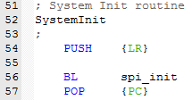

This function has one parameter: R0 – address of receiving buffer in DATA memory (ADDR_TO_STORE).

The function should initialize all your variables. For example:

def spi_init(buffer):
ADDR_TO_STORE = buffer # Parameter passed throw R0
RX_DATA = 0
BIT_COUNT = 0
# any other variables you may use...

You will need to declare some buffer in DATA memory to store received bytes. It not need to be large. 8 – 16 bytes is ok. For example:

spi_buffer
SPACE 8

You may declare it next to declaration of your variables.

4. Check your functions with both ‘spi_input’ and ‘spi_input_1’ data sets.

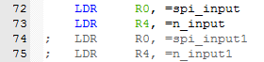

‘spi_input_1’ data set is to check if SS line is working. Couple of bytes is transmitted with SS in High state. Those symbols should not appear in receiver buffer.

Ask your questions by e-mail! You will be answered promptly!
Good luck!

